**Lab 2: Launch Your Instance**

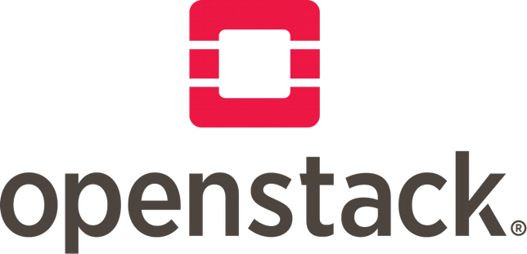

# Objectives:

This lab will walk you through the process of launch a small test instance on your OpenStack lab using Dashboard (Horizon). An instance, also called a virtual machines, is an individual instance of an image that is created upon request and configured when launched. You will start from login into the dashboard, set basic setting for the instance, to its deletion and termination.

## Log in the OpenStack dashboard

Dashboard is a web interface for us to operate OpenStack using a friendly graphical website. Please open your browser and input the website shown at the end of completion of DevStack.

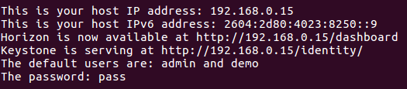

Log in using username demo and your password set in the Lab1. If you installed an old version DevStack, you may need to enter the domain. Please enter “default”.

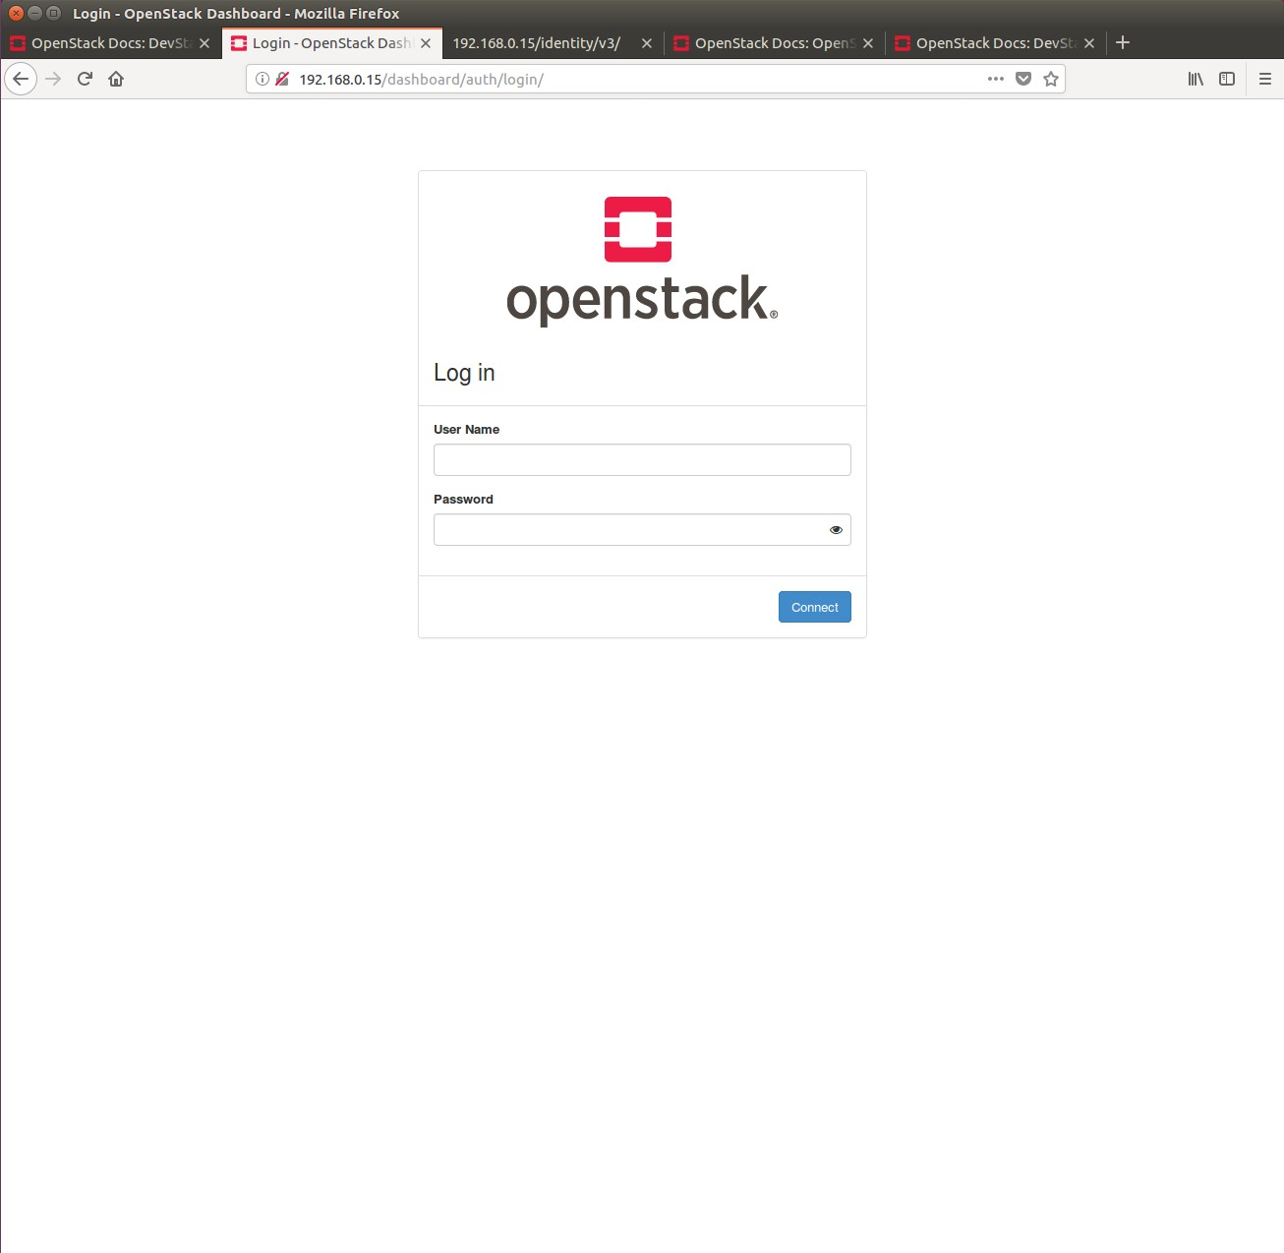

## Check the network topology

From the left column of tags on your web page, choose “Network option”. Then click “Network Topology”. You can see the architecture of the demo project. Two networks are shown: public network connected to external Internet and private network built in the OpenStack virtual network. The two networks are bridged with a virtual router. The IP domain of the private network can be configured in the “local.conf” file when installing devstack. Here we can use the default 10.0.0.0/26 subnet.

You can choose the displays of network topology by clicking “Topology” or “Graph” based on your preference.

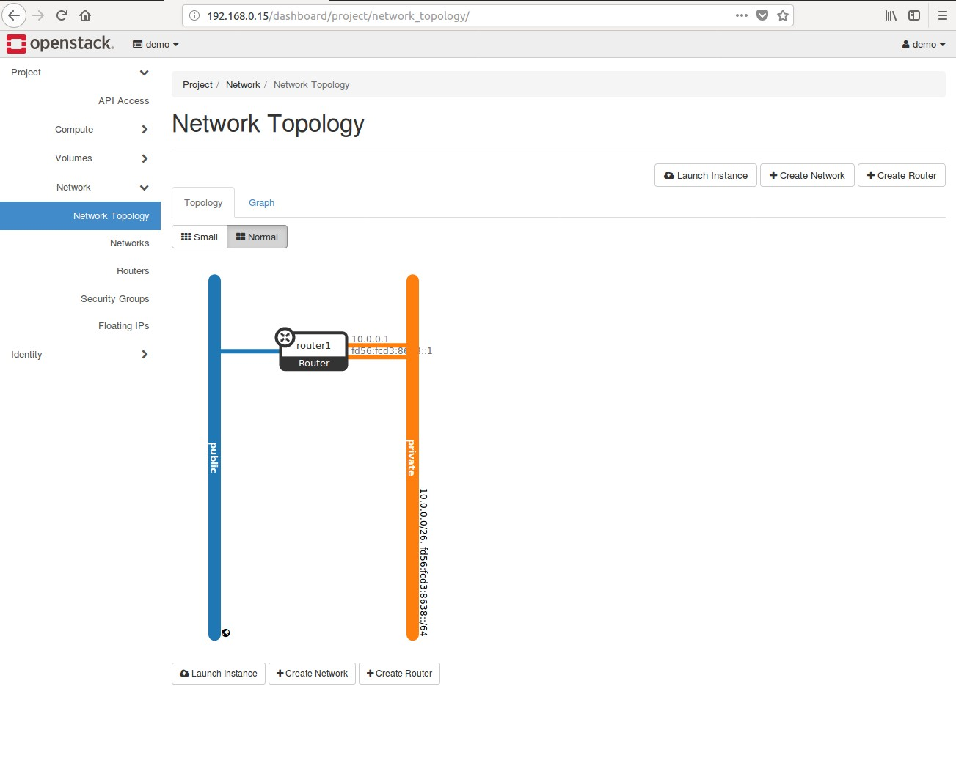

**3. Start launching a new VM instance**

Now we start to launch your first virtual machine, also called a server on the private network. This service is provided by Nova, the computing service of OpenStack.

Click the “Compute” on the left website page, then choose “Instances”. There is no instances existed now so you will get an empty list.

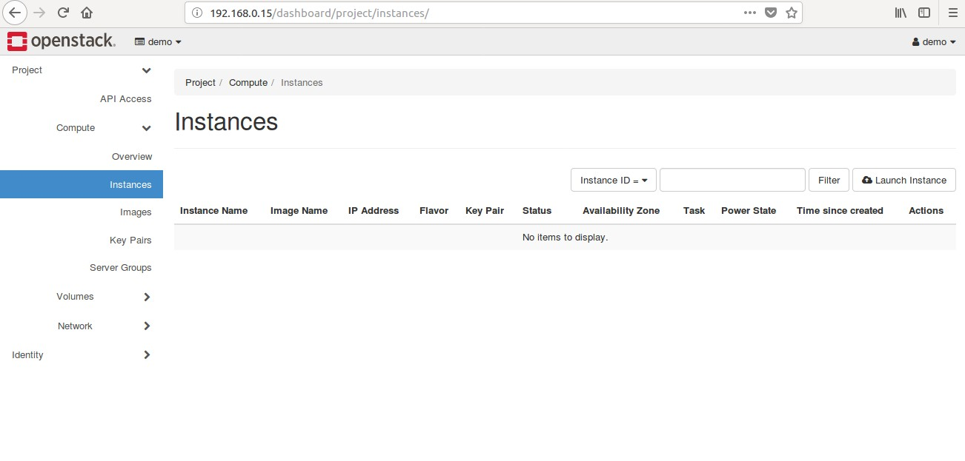

Click on “Lauch Instance” marked on above figure.

## Set basic setting for the instance

There are a few settings in order to launch your instance. You will notice that some settings are required and some are optional. We will introduce them step by step.

Details:

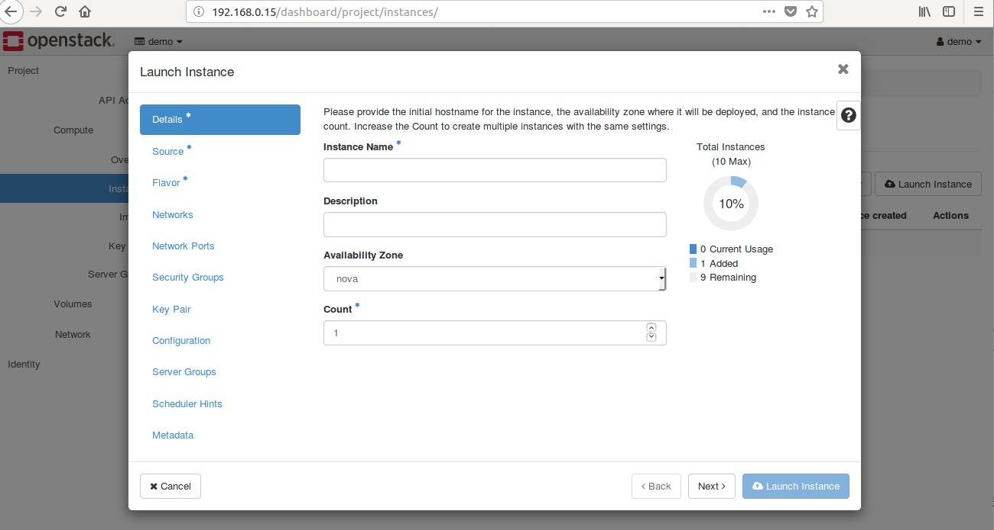

1. Pick a “Instance Name” you wish
2. Add some “Description” for your instance
3. “Availability Zone”: we only have one zone -- nova.
4. Decide how many numbers of instances to launch. Default: 1. Source:

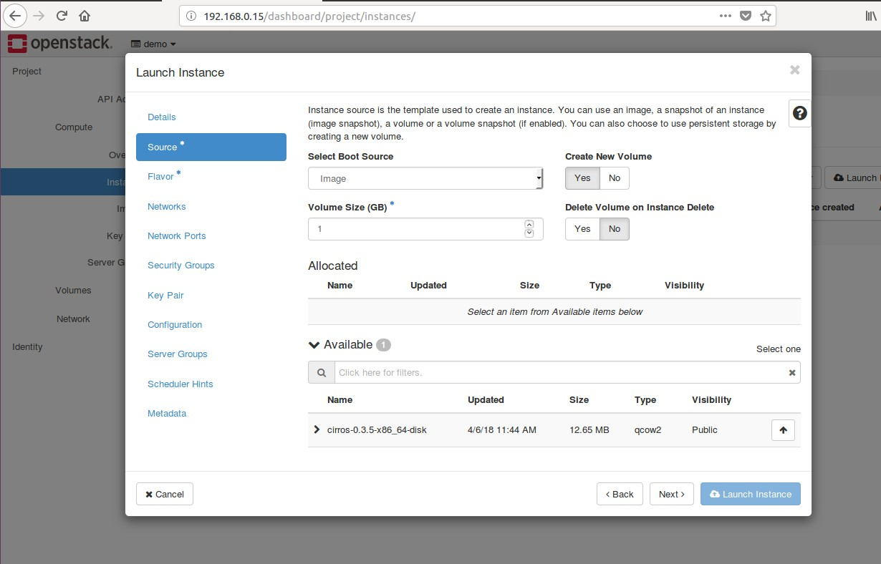

1. Choose Image for the “Select Boot Source” since you do not have other kinds of sources now.
2. You can choose create a new volume or not. If you launch a instance with a volume, the instance is persistent and its data will not be deleted even if the instance is terminated. Without volume, the instance is ephemeral.
3. Click the up arrow to choose the only available image, “cirros”. Cirros is a minimum image to test the Nova functions.
4. Keep the default choices for other options.

Flavor:

Choose the sizing for the compute, memory and storage capacity of the instance. Here we choose “m1.micro” that is enough for cirros.

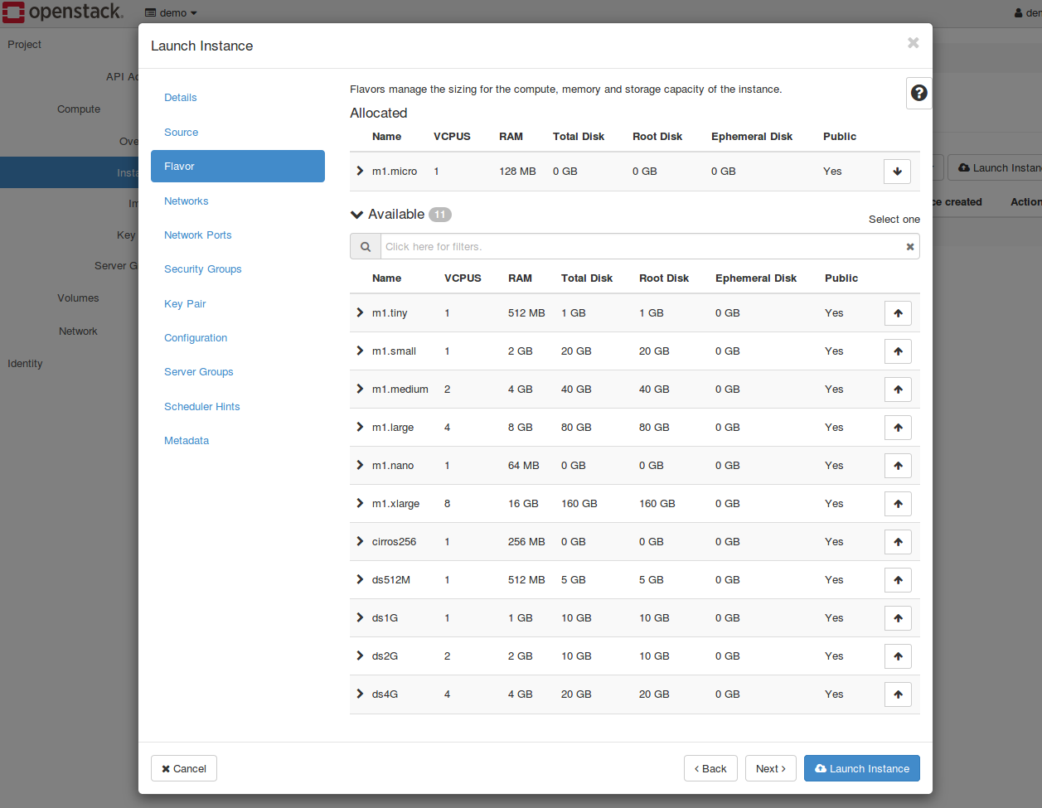

Networks:

Now add a network to the instance. Click on the arrow of private network.

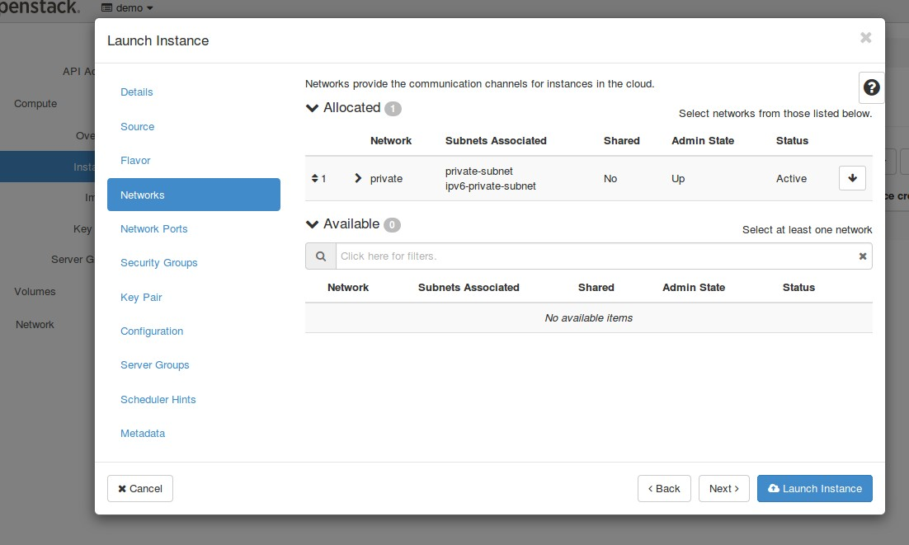

Security Groups:

Security Groups shows the groups with different security configuration of network such as UDP, TCP, ICMP, SSH and etc. Here you can choose the “default”. We will learn how to create a new group in the advanced lab.

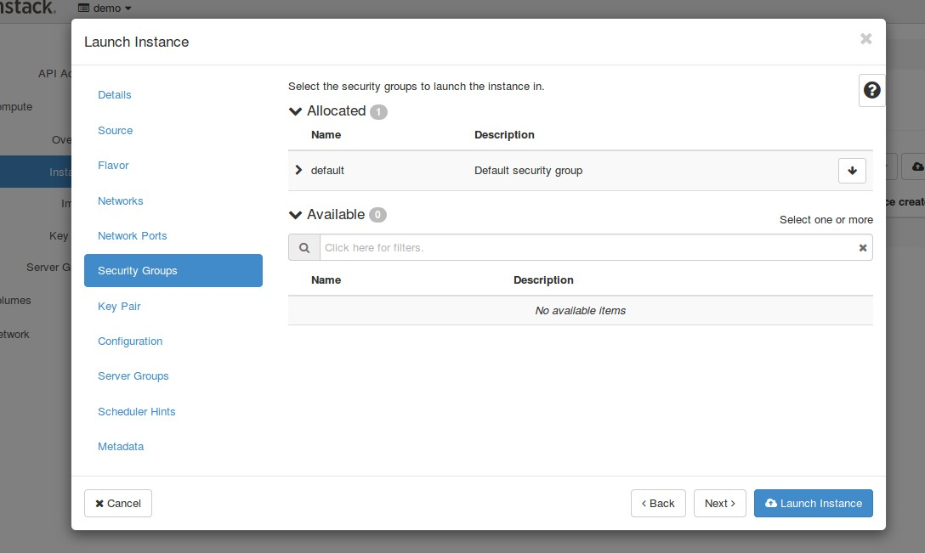

Launch and wait for your instance to boot:

Now you can click the “Launch Instance” button. Please observe what will happen.

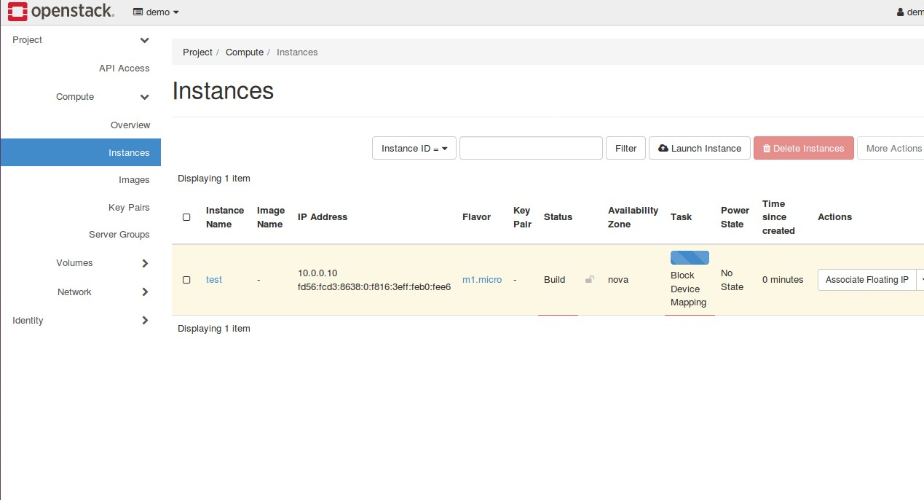

The status of “Power State” will follow several changes: Block Device Mapping, Spawning and Running. The whole process will take about 10 seconds. If you are launching some big size image like Ubuntu or add more settings, the processing time may be up to several minutes. The instance is assigned a private IP automatically.

## Check the status of your instance:

Click the name of the instance.

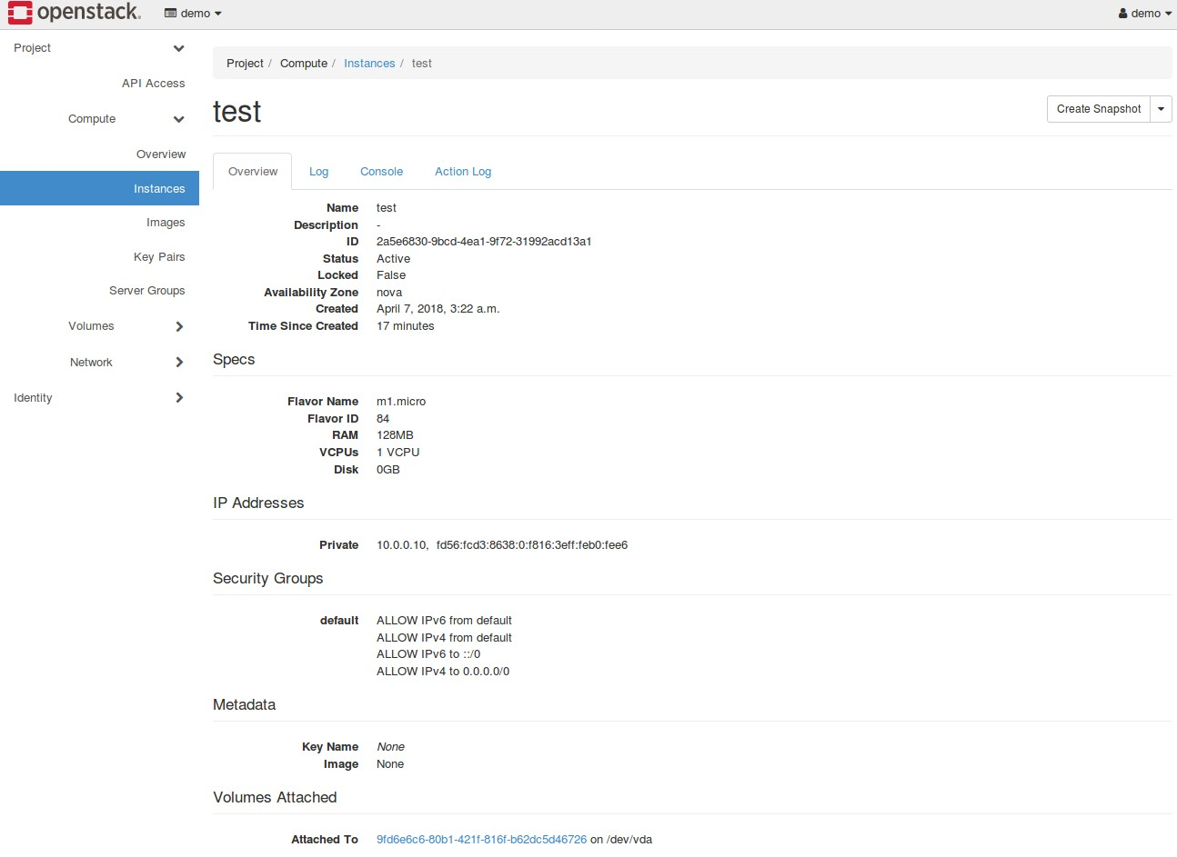

You can switch tags between “Overview”, “Log”, “Console” and “Action Log”.

In the “Overview” section, you can check the specific setting information and detailed security rules.

In the “Log” section, the logs of the launching process are recorded. And the latest logs shows the username and login password for the cirros system.

In the “Console” section, a empty console window appears. You should press any keys on your keyboard to wake the console. If it is not effective, please click “Click here to show only console” to open a fullscreen model of the console. Then you can use keyboard to login to cirros.

After you log into cirros, you can test some basic linux command like “ls” or “mkdir”.

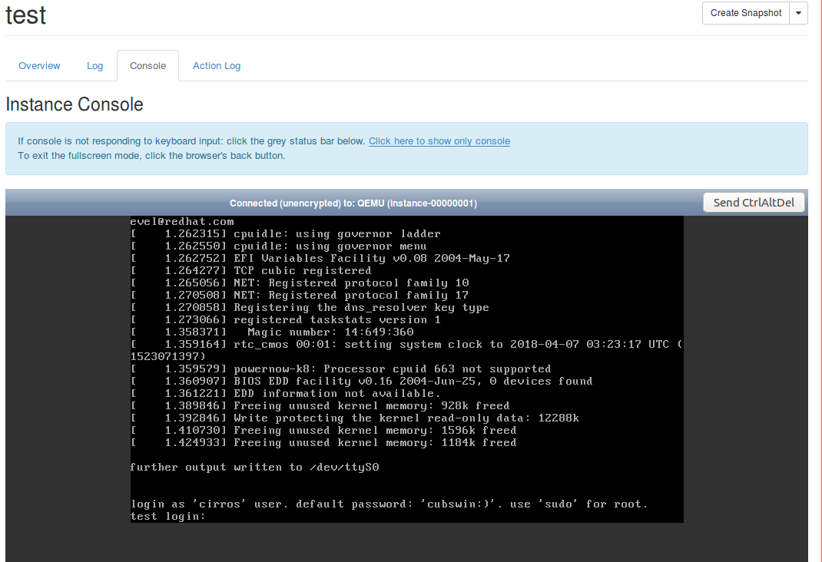

## Suspend/Pause/Delete/Resume the instance:

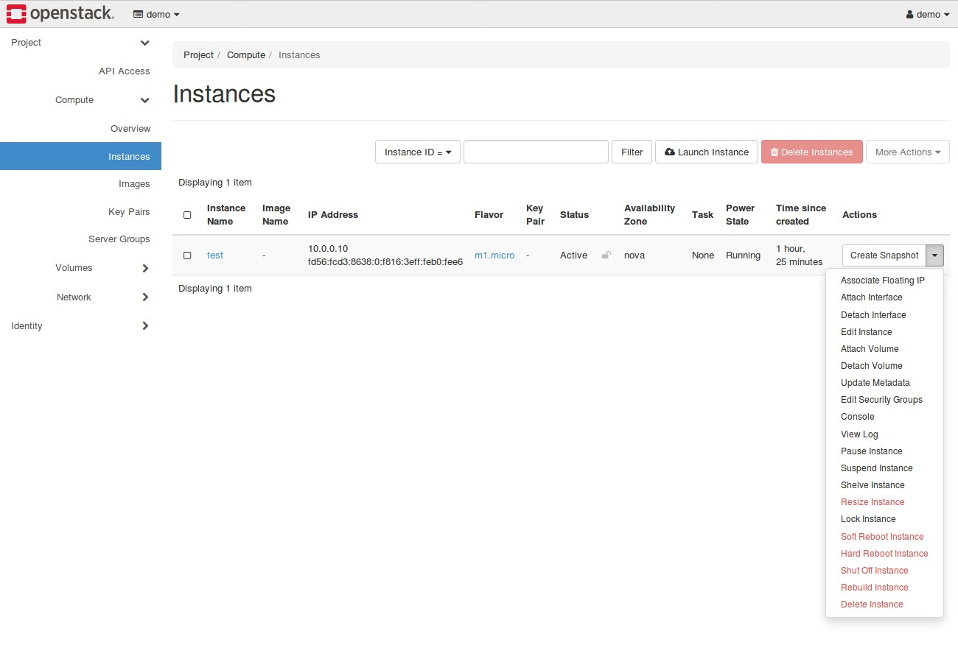

Back to the “Compute → Instance” page, there are “Actions” options with a drop-down list. You can choose the corresponding options you want. Please observe the Status changes once you perform an action.

# What to Hand in

1. Please compare the dashboard of “Compute → Overview” before and after the launching of your instance.
2. Please take notes for all your settings when you launch the cirros instance. Organize them in the order of the setting steps.
3. Log in your cirros system and make a directory named with “YourName+Date”. Submit a screenshot.
4. Try to suspend, pause, resume your instance. Take a screenshot for each status. Please discuss the difference of their status.